2020 World Schools Debate Invitational
SCHOOL TEAM APPLICATION

One Eastern Missouri NSDA affiliated high school will be selected to field the “Single School Team” to represent the District at the 2020 USA World Schools Debate Invitational. This tournament will be held in conjunction with the National Speech and Debate Association’s National Tournament June 13th – 220th, 2020 in Albuquerque.

To be eligible to field the Single School Team, a school must adhere to the following criteria:
- Be affiliated in good standing with the Eastern Missouri NSDA District
- Submit a bid listing 3 – 5 eligible students that meet these requirements:
  - All students must be bona fide members of the NSDA Honor Society
  - At least three students must have earned a minimum of 250 NSDA Honor Society points over the course of their lifetime; a minimum of 150 points must have been earned during the current season.
  - The remaining two seats are optional and can be filled at the discretion of the team’s coach. The inclusion of one underclassman (who is not held to the 250/150 point rule) is highly encouraged.
- Agree to furnish a COACH and a JUDGE for the duration of the WSD Invitational. This can be the same person.
- Agree to fund (either through budget expenditure or fundraising) all costs associated with taking the team to the World Schools Debate Invitational.

The school selected will be expected to work in close conjunction with the 2020 WSD Hybrid Team from Eastern Missouri once it is established.

INSTRUCTIONS FOR SUBMISSION:

- Download this document and open in MSWord.
- Complete the application, then save the document in MSWord or PDF formats.
- Upload the document to the form at www.eastmoforensics.com/world-schools-debate. You’ll receive a confirmation within 24 hours.

Applications MUST be submitted by a school’s COACH. The Eastern Missouri NSDA District presumes that the coach has already received administrative approval to submit the bid. Bids submitted from students, parents, or school employees not on file in the NSDA Point Application will automatically be rejected unless accompanied by proof of administrative approval.

APPLICATION DEADLINE:
MARCH 25TH, 2020

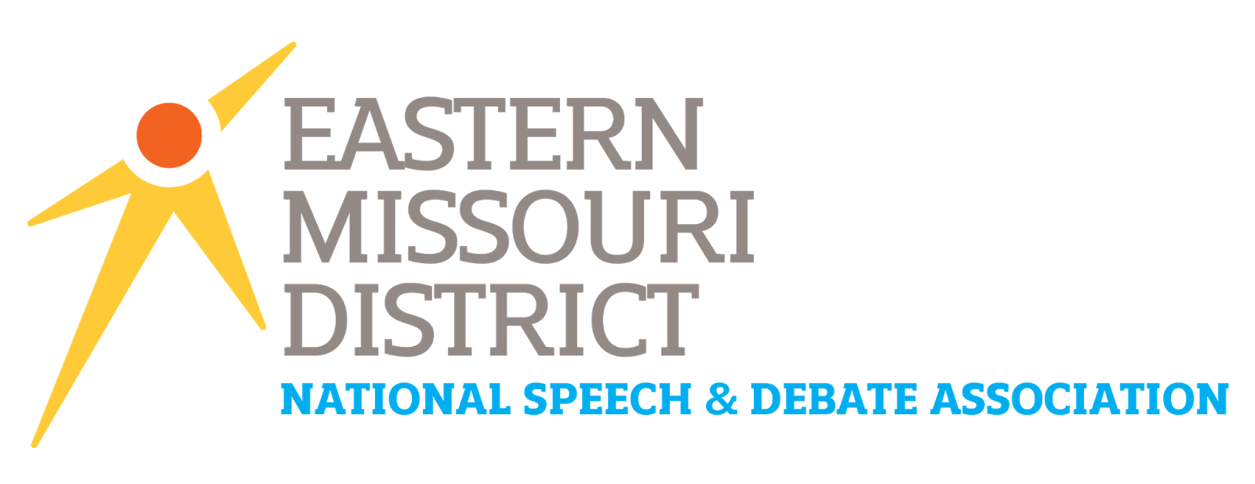
2020 WORLD SCHOOLS DEBATE
SINGLE SCHOOL TEAM APPLICATION

PART ONE: SCHOOL INFORMATION

HIGH SCHOOL:
SCHOOL HEAD COACH:
HEAD COACH EMAIL:

If selected, who will serve as this team’s COACH at the 2020 WSDI?
If selected, who will serve as this team’s JUDGE at the 2020 WSDI?
# of National Tournament Appearances prior to 2020:
This information can be provided by the District Chair.
# of National Qualifiers in 2020:
(Not counting potential WSD qualifiers)

PART TWO: AGREEMENTS
By submitting this application, the coach of the school is attesting to the following provisions:

- Top of Form
- If selected, our school agrees to cover the financial cost of sending this team to the 2019 World Schools Debate Invitational, June 13th – 20th, 2020 in Albuquerque, New Mexico. (Financial information can be found at www.speechanddebate.org or by contacting your District Chair).

- If selected, our school will work closely with the 2020 Eastern Missouri WSDI Hybrid team once established.

- We acknowledge that entering the World Schools Debate Invitational requires an adult chaperone, a team coach, and a judge to be with the team through the week-long tournament. One person can serve all three roles at the same time.

- We acknowledge that the Eastern Missouri NSDA District Committee will presume that we have already received administrative approval to take this team to the 2020 WSDI/NSDA National Tournament. If we are selected, we will attend.

Bottom of Form
PART 3: STUDENT IDENTIFICATION

Please identify the students who will sit on this team if your school is selected:

Per Eastern Missouri NSDA regulation, the team must be composed in the following way:
- Seats ONE, TWO, and THREE must be filled by a student with a minimum of 250 NSDA points over their lifetime and have earned a minimum of 150 points in the 2019-2020 school year on record in the NDSA Point Application prior to the start of the District Tournament.
- Seats FOUR and FIVE may be filled by any bona fide NSDA student member from your school. The inclusion of an underclassman is highly encouraged.

All students MUST be bona fide members of the NSDA Point Application.
SEAT | STUDENT NAME | CLASS OF | LIFETIME NSDA PTS | 2018-19 NSDA Points Earned as of 3/14/2020*
1
2
3
4
5
*excludes points earned at 2020 Eastern Missouri NSDA Congress Districts, but CAN include 2020 MSHSAA Districts.

PART 4: ESSAY QUESTIONS

Question 1: Considering your selected students, the coach(es), and your team dynamics, what qualities do you believe will make this team competitive at the World Schools Debate Invitational?

Question 2: What do you see as proof/good indications that these students will well together and will put forth the work-ethic expected? Eastern Missouri wants to select a team that will represent us well and be worthy of earning the only single-school slot.

Question 3: What makes your team UNIQUE and especially deserving of this slot to Nationals?

FINAL SUBMISSION:

- Coaches may attach pages if they need additional space to answer any of the above questions.
- Additional documentation to further a coaches’ argumentation for their team are also accepted if attached to this application.
- Applications should be uploaded via www.eastmoforensics.com/world-schools-debate. A confirmation will be sent to the school’s head coach within 24 hours. Applications MUST come from a recognized coach!

