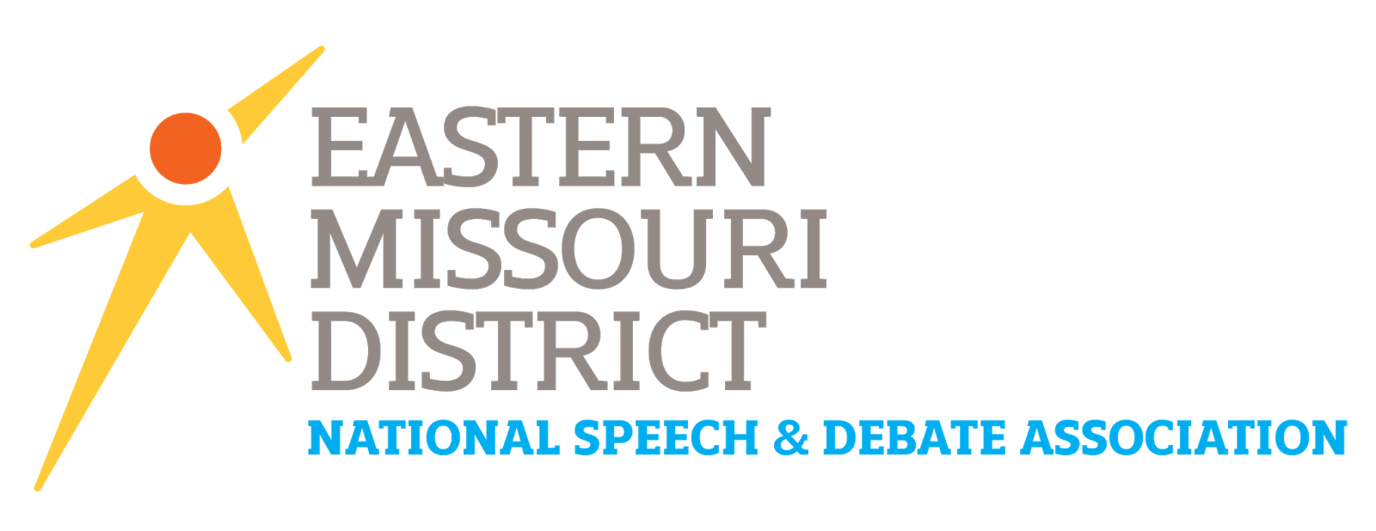
2020 WORLD SCHOOLS DEBATE
HYBRID TEAM APPLICATION

PART ONE: SCHOOL INFORMATION

HIGH SCHOOL:
SCHOOL HEAD COACH:
HEAD COACH EMAIL:

PART TWO: STUDENT PRIORITIZATION

To be considered, students must meet the following stipulations:
- Be a standing senior at a high school affiliated with Eastern Missouri NSDA.
- Graduate high school prior to June 14th, 2020.
- Have earned a minimum of 250 NSDA Points over their lifetime, an at least 150 points during the current school year prior to the start of the 2020 NSDA Speech & Debate District Tournament.
- Not be from the school selected to serve as the Single School Team.
- Not have qualified to the 2020 NSDA National Tournament in another event.

The 2020 WSD Selection Committee receives very specific instructions for how to determine which students will sit on the Hybrid Team. These are outlined in the Selection Process Document. The expectation is that the hybrid team represents FIVE different schools, meaning that no school should have more than one student on the team. The only exception will come if the Selection Committee cannot create a team of five qualified students without repeating from a school.

As such, coaches are provided the opportunity to list students, in order of priority, for consideration. Only students listed below will be considered, and they will ONLY be considered in the order that a coach lists.
Priority | Student Name | Lifetime NSDA Points | 2019-20 NSDA Points Earned as of 3/14/2020*
1st
2nd
3rd
4th
5th
*excludes points earned at the 2020 Eastern Missouri NSDA Congress Districts, but CAN include points from 2020 MSHSAA Districts.
PART THREE: AGREEMENTS
By submitting this application, the coach of the school is attesting to the following provisions:

- If my student is selected for the hybrid team, a coach from my school MUST travel with the student in accordance with NSDA regulations, MSHSAA regulations, local and state laws, and my school district’s policies.
- If my student is selected for the hybrid team, my school will be responsible for the student’s entry fee, travel, meals, and lodging. (Financial information can be found at www.speechanddebate.org or by contacting your District Chair.)
- After the students for the hybrid team are determined, the 2020 WSD Selection Committee will select an adult from one of the represented schools to serve as the COACH and JUDGE for the Hybrid Team. I will be considered for this role. Regardless of who is selected, my students and I agree to trust the decisions of the WSD Hybrid Team’s coach and work with them closely in preparation for competition.
- If my student is selected, he or she is expected to contribute heavily to the success of the Hybrid Team. This includes regular practice with the Eastern Missouri Single-School Team.
- I acknowledge that the Eastern Missouri NSDA District Committee will presume that I have already received administrative approval to take this student to the 2020 WSDI / NSDA National Tournament, June 13th – 22nd, 2020 in Albuquerque, New Mexico. If selected, my student WILL compete!
- I have read and understand the determination process for the Hybrid Team.

The coach electronically ‘signs’ this document when submitting it via email attachment to the District Chair.

INSTRUCTIONS FOR SUBMISSION:

- Download this document and open in MSWord.
- Complete the application, then save the document in MSWord or PDF formats.
- Submit the application via the form at www.eastmoforensics.com/world-schools-debate. A confirmation will be sent to the school’s head coach within 24 hours.

Applications MUST be submitted by a school’s COACH. The Eastern Missouri NSDA District presumes that the coach has already received administrative approval to attend the 2020 WSDI / NSDA National Tournament should the student be determined to have qualified to the hybrid team.

APPLICATION DEADLINE:
April 24th, 2020

